Project Report On
Candlestick Pattern Recognition
Submitted By:
Milroman Singh
Abhijeet Singh
Jashanpreet Singh
Jaspreet Singh
Under the Guidance of:
Sushrut Nagula



Centre for Development of Advanced Computing A-34, Industrial Area, Phase-VIII Sahibzada Ajit Singh Nagar (Mohali), Punjab – 160071

Abstract
Manual identification of candlestick patterns from stock charts is time-consuming and prone to human error. This project presents a hybrid Computer Vision and Machine Learning system that automates candlestick pattern recognition from chart images. Historical OHLC (Open, High, Low, Close) data is used to generate a labeled dataset via rule-based technical-analysis definitions, rendered as chart images using the mplfinance library. An OpenCV-based pipeline consisting of grayscale conversion, adaptive thresholding, morphological cleaning, and contour detection isolates individual candlesticks from each image and measures their geometric properties directly from pixels.
These measurements are converted into scale-invariant ratio features and used to train and compare four classical machine learning classifiers — Support Vector Machine, Random Forest, Decision Tree, and K-Nearest Neighbors — across six candlestick patterns: Doji, Hammer, Shooting Star, Bullish Engulfing, Bearish Engulfing, and Spinning Top. Random Forest achieved the best performance with a 96.3% F1-score and was deployed in a Streamlit web application supporting both direct image upload and live stock-ticker input. Beyond pattern classification, the system also generates a graded trading recommendation — Strong Buy, Buy, Hold, Strong Sell, or Sell — by combining the predicted signal with the model's confidence score. The results confirm that classical, interpretable machine learning is sufficient for this well-structured problem, without requiring deep learning.
Table of Contents
1. Introduction
2. Objectives
3. Literature Survey
4. Existing System
5. Proposed System
6. System Architecture
7. Modules
8. Technologies Used
9. Working Procedure
10. Results
11. Advantages
12. Disadvantages / Limitations
13. Applications
14. Future Scope
15. Conclusion
Introduction
Candlestick charts are one of the most widely used tools in technical analysis of financial markets. Each candlestick visually encodes four price points for a given time period — open, high, low, and close — and specific arrangements of one or more candlesticks form recognizable “patterns” that traders interpret as signals of likely future price movement.
Manually scanning charts to spot these patterns is slow, subjective, and error-prone, particularly for traders who are still developing pattern-recognition intuition. This project automates the process end-to-end: given a candlestick chart image, or simply a stock ticker symbol, the system detects the relevant candlestick(s) using computer vision, extracts quantitative geometric features, classifies the pattern using a trained machine learning model, and returns a trading interpretation — a Bullish, Bearish, or Neutral signal, further graded into a Buy/Sell recommendation based on model confidence.
The project was undertaken as a summer training project, combining concepts from image processing, feature engineering, and classical machine learning into a single, testable, deployable application.
Objectives
- To preprocess candlestick chart images using computer vision techniques to isolate candle regions.
- To detect and segment individual candlesticks from a chart image using contour analysis.
- To extract quantitative geometric features (body size, wick lengths, ratios) from each detected candle.
- To train and compare classical machine learning models — SVM, Random Forest, Decision Tree, and KNN — for six-class pattern classification.
- To build a prediction pipeline that accepts either an uploaded chart image or a live stock ticker.
- To generate a trading signal and a graded Buy/Sell recommendation based on model confidence.
- To develop a Streamlit-based web interface for end-user interaction.
- To evaluate the system using standard classification metrics and automated software testing.
Literature Survey
Existing research on candlestick pattern recognition has largely converged on deep learning approaches applied to image-like encodings of price data. One prominent method encodes OHLC time series into images using the Gramian Angular Field technique, and then trains a convolutional neural network to learn candlestick patterns from these encoded images. Other work has extended into direct image-based object detection: a fine-tuned YOLOv8 model has been used to identify candlestick chart patterns in real time, trained on a dataset of roughly 9,000 chart images and reaching approximately 93% training accuracy. Tsai et al. similarly proposed an extended CNN-based approach specifically for automated candlestick pattern recognition, reflecting a broader trend of applying deep computer-vision techniques to this domain.
However, deep learning is not universally necessary for this task. A comparative study evaluating MLP, CNN, AdaBoost, Random Forest, and XGBoost on GAF-encoded candlestick images found that traditional machine learning models could match or exceed deep learning performance, concluding that complex CNN architectures are not strictly required for satisfactory candlestick classification accuracy. This finding directly supports the design choice made in this project: rather than encoding whole images for a CNN, interpretable geometric features (body and wick ratios) are extracted and used with classical machine learning — a lighter-weight approach consistent with evidence that engineered features can be competitive with deep learning for this specific problem.
It is also worth noting a gap in existing literature that this project's scope deliberately reflects: much of the existing research on candlestick pattern recognition using machine learning remains limited to a relatively small number of patterns, rather than the full traditional taxonomy of dozens of named patterns. This project follows the same deliberately narrow-but-deep approach, targeting six well-defined single- and dual-candle patterns.
Existing System
At present, candlestick pattern identification is performed almost entirely manually by traders and analysts, typically by visually scanning price charts on trading platforms or broker applications. Some platforms offer basic rule-based pattern-highlighting tools, but these are often limited to a small set of platform-specific rules, are not easily explainable, and are not adaptable to a trader's own definitions of a pattern.
This manual, or semi-automated, approach has several drawbacks:
- It is time-consuming, especially when scanning many stocks or long historical charts.
- It is subjective — different traders may classify the same candle differently.
- It does not scale — a human cannot realistically monitor hundreds of tickers continuously.
- Existing automated tools are largely closed-source and do not expose the underlying detection logic, making their outputs difficult to trust or verify.
Proposed System
The proposed system automates candlestick pattern recognition using a transparent, explainable pipeline built from computer vision and classical machine learning, rather than a black-box deep learning model. Given a chart image or a stock ticker, the system:
- Preprocesses the input image using grayscale conversion, thresholding, and morphological operations.
- Detects individual candlesticks using contour analysis and separates each candle's body from its wicks.
- Computes scale-invariant geometric ratio features from the detected candle(s).
- Classifies the pattern using a trained Random Forest model, selected after comparing four candidate algorithms.
- Returns the predicted pattern, a Bullish/Bearish/Neutral trading signal, a graded Buy/Sell recommendation, and a confidence score.
Every design decision in the proposed system is deliberately interpretable: the features fed to the model are the same style of geometric ratios (body-to-range, wick-to-body) that define each pattern in traditional technical analysis, so the model's behaviour can be explained and verified rather than treated as opaque.
System Architecture
Process Flowchart
Both supported input modes — uploading a chart image directly, or entering a stock ticker — converge into the same detection and classification pipeline, ensuring consistent behaviour regardless of input method.
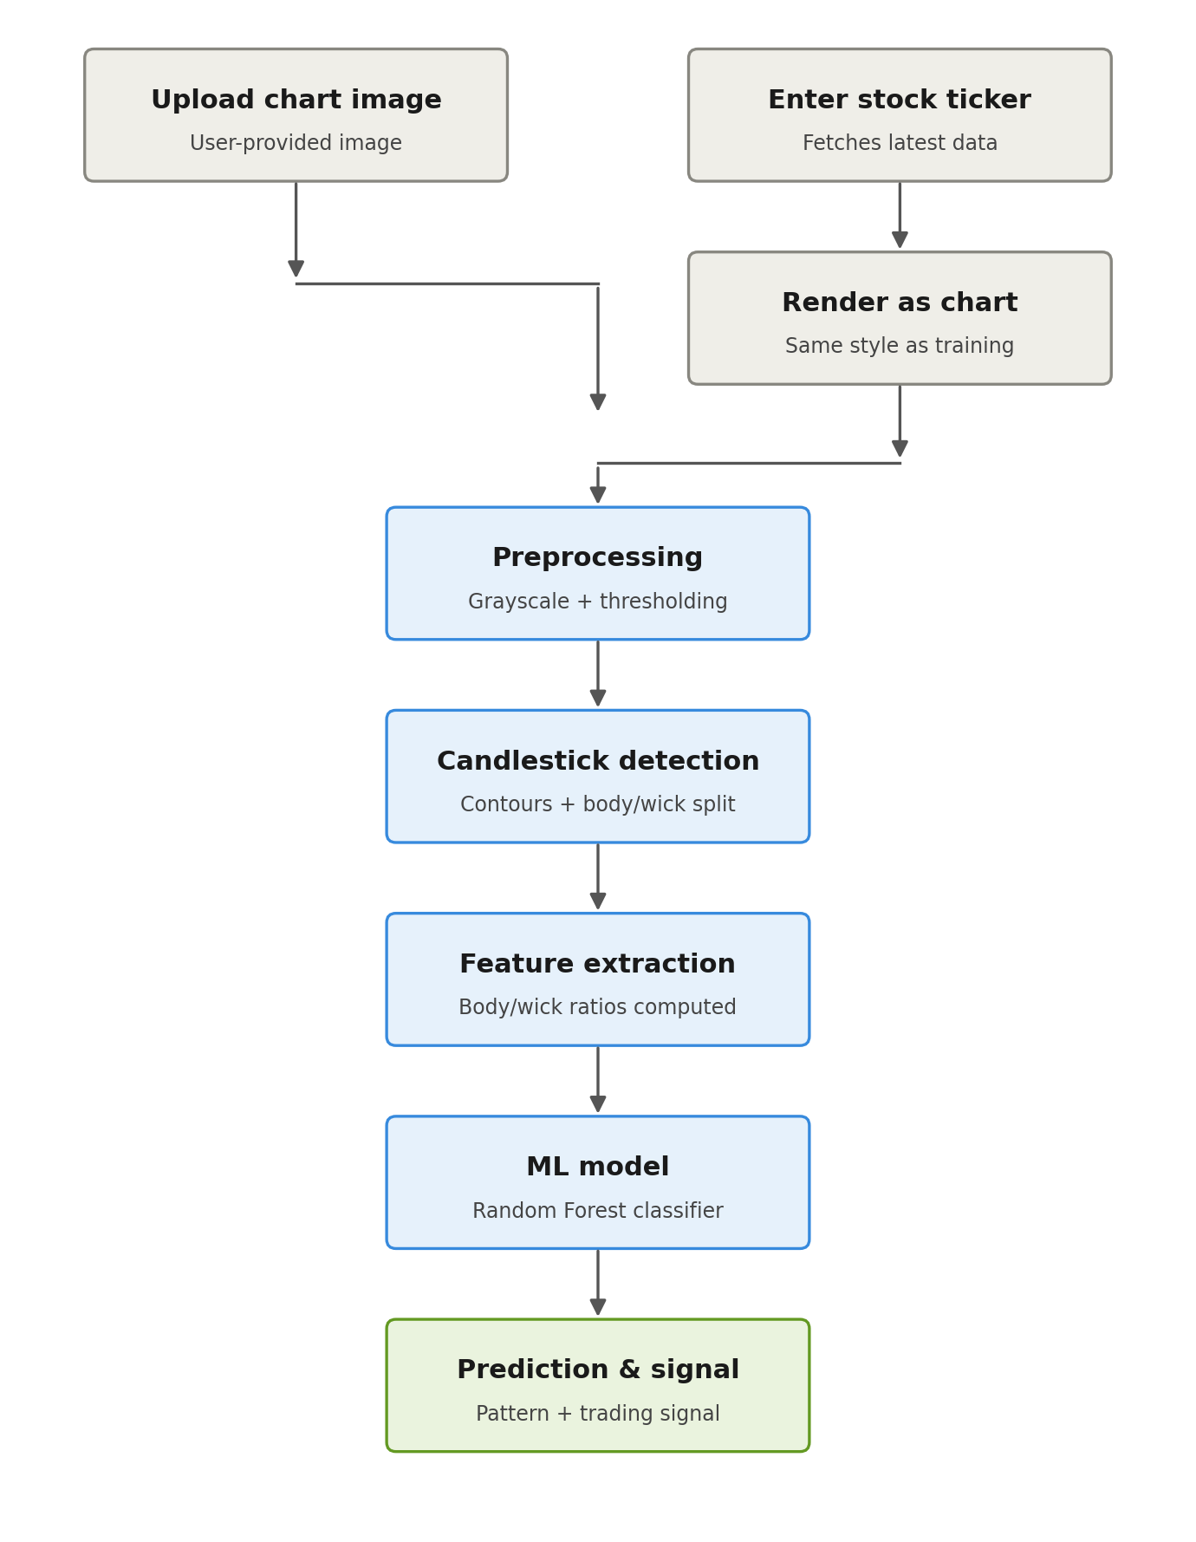
Figure 1: End-to-end system flowchart
Module-Level Architecture
The diagram below maps the processing pipeline onto the project's actual code organization, showing how each folder-level module depends on the ones before it.
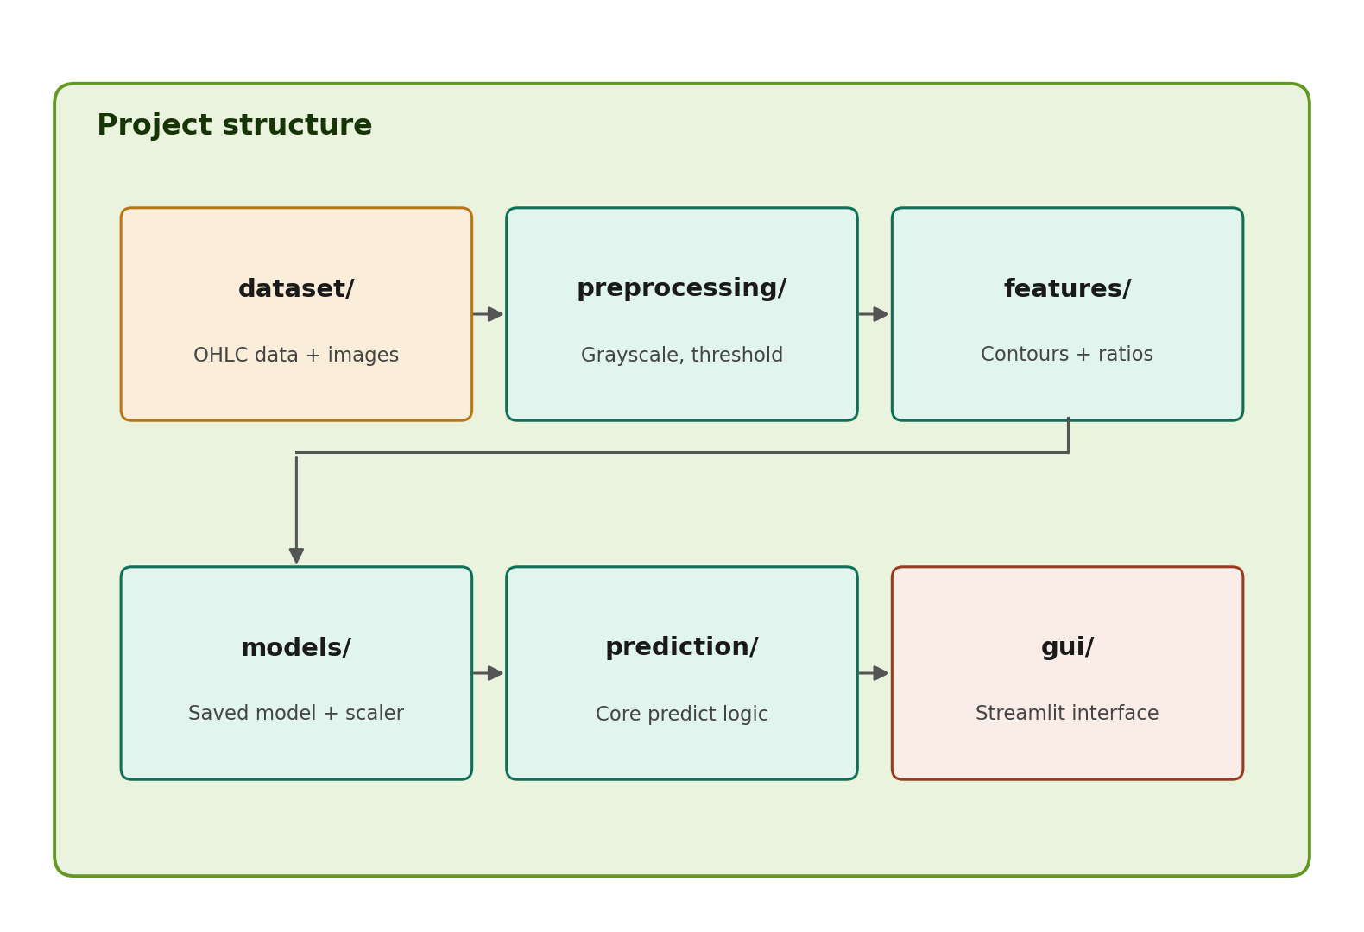
Figure 2: Project module structure and dependency flow
Modules
Dataset Generation Module
Fetches historical OHLC data via yfinance across thirteen tickers spanning NSE and US markets, applies rule-based technical-analysis definitions to identify pattern matches, and renders labeled six-candle chart images using mplfinance.
Preprocessing Module
Converts input images to grayscale, applies binary thresholding, removes noise via median blur, and refines the result using morphological closing to produce a clean binary mask of the candlestick shapes.
Candlestick Detection Module
Applies contour detection to the binary mask to isolate each candle, then separates the wide body region from the narrow wick regions using a row-wise pixel-width scan, and determines bullish/bearish direction from color.
Feature Extraction Module
Converts detected pixel measurements into four scale-invariant ratio features for the last two candles in an image, producing a fixed-length feature vector for all pattern classes.
Model Training Module
Trains and compares SVM, Random Forest, Decision Tree, and KNN classifiers on an 80/20 stratified split, saving the best-performing model and its feature scaler to disk.
Prediction Module
Provides a unified prediction function that accepts either an uploaded image or a stock ticker, internally reusing the same detection and feature-extraction logic used during training, and returns the pattern, signal, recommendation, and confidence.
GUI Module
A Streamlit-based web interface exposing both input modes, displaying the detected pattern, chart preview, trading signal, and graded Buy/Sell recommendation.
Technologies Used
- Python — primary programming language
- OpenCV — image preprocessing and candlestick detection
- NumPy and Pandas — numerical and tabular data handling
- yfinance — historical stock market data retrieval
- mplfinance and Matplotlib — candlestick chart rendering and visualization
- scikit-learn — model training (SVM, Random Forest, Decision Tree, KNN) and evaluation
- joblib — model and scaler persistence
- Streamlit — web-based graphical user interface
- pytest — automated testing framework
- PyCharm — integrated development environment
Working Procedure
Step 1 — Data Collection
Historical daily OHLC data is downloaded for each ticker using the yfinance library and cached locally as CSV files.
Step 2 — Rule-Based Labeling
Each candidate candle (or candle pair) is checked against precise mathematical definitions of the six target patterns, based on body-to-range and wick-length ratios.
Step 3 — Image Rendering
Matching six-candle windows are rendered as chart images using mplfinance, then randomly sampled to produce a balanced dataset of approximately 200 images per class.
Step 4 — Preprocessing
Each chart image is converted to grayscale, thresholded, denoised, and cleaned using morphological operations to produce a binary mask suitable for contour detection.
Step 5 — Detection
Contours are extracted from the binary mask, sorted left to right, and each candle's body and wick boundaries are determined via a row-wise width scan.
Step 6 — Feature Extraction
Body and wick measurements for the last two candles are converted into four scale-invariant ratio features plus a bullish/bearish flag, forming an eleven-column feature vector.
Step 7 — Model Training
The feature dataset is split into training and test sets (80/20, stratified), features are standardized, and four classifiers are trained and evaluated.
Step 8 — Prediction
For a new input (image or ticker), the identical preprocessing, detection, and feature-extraction steps are applied, and the trained Random Forest model predicts the pattern and a confidence score.
Step 9 — Signal and Recommendation Generation
The predicted pattern is mapped to a Bullish/Bearish/Neutral signal, which is further combined with the model's confidence to produce a graded recommendation: Strong Buy, Buy, Hold, Sell, or Strong Sell.
Step 10 — Display
The Streamlit interface displays the input chart, the detected pattern, the signal, the recommendation, and the confidence score to the user.
Results
Preprocessing and Detection Output
The figure below shows actual output from the project's OpenCV pipeline, applied to a generated Hammer-pattern sample, progressing from the original color chart through grayscale conversion, thresholding, noise removal, and morphological cleaning.
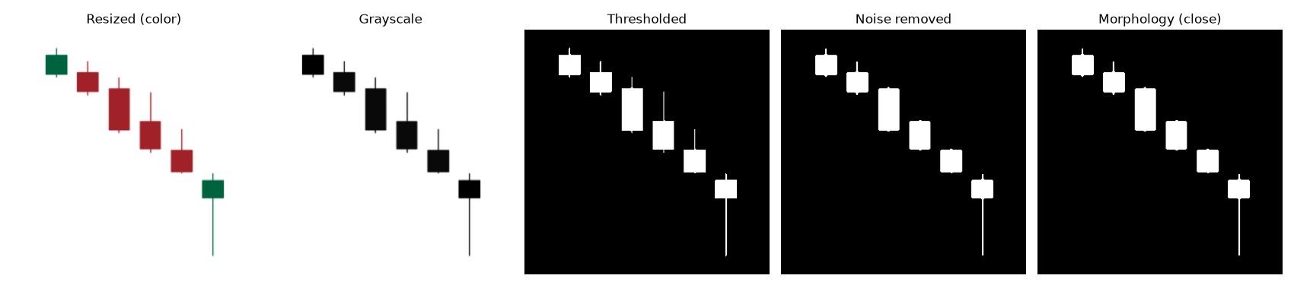
Figure 3: Preprocessing pipeline output
Model Comparison
Four classical machine learning models were trained and evaluated on the extracted feature set using an 80/20 stratified train-test split. Results are summarized in the table below.
Model | Accuracy | Precision | Recall | F1-Score
Random Forest (final) | 0.963 | 0.964 | 0.962 | 0.963
Decision Tree | 0.921 | 0.925 | 0.921 | 0.921
SVM | 0.908 | 0.910 | 0.908 | 0.908
KNN | 0.892 | 0.892 | 0.892 | 0.890

Key Findings
- Tree-based models (Random Forest, Decision Tree) outperformed SVM and KNN, consistent with features that were engineered from threshold-based rules in the first place.
- Doji was the most-confused class across all four models, traced to pixel-measurement noise near its tight body-ratio boundary against Spinning Top.
- The system met the sub-2-second prediction requirement, confirmed via an automated performance test.
- A pytest-based test suite (15 tests) covering pattern-labeling rules, detection consistency, edge-case handling, and performance all passed successfully.
- A real-world test revealed that the system does not currently support dark-themed chart screenshots, documented as a known limitation.
Advantages
- Fully automated — removes the need for manual chart scanning.
- Interpretable — features and model decisions are traceable to explainable geometric rules, unlike black-box deep learning approaches.
- Fast — predictions complete in under two seconds, verified through automated testing.
- Flexible input — supports both direct image upload and live ticker-based lookup.
- Extensible — modular design allows new patterns or models to be added with minimal changes to existing code.
- Actionable output — provides not just a pattern name but a graded trading recommendation with a confidence score.
Disadvantages / Limitations
- Assumes a light chart background with darker candles; dark-themed screenshots invert the thresholding logic and produce unreliable detection.
- Uploaded images should show a small number of recent candles at a zoom level similar to the training data; full multi-month or multi-year charts distort the extracted feature ratios.
- Ticker-based input reflects the latest available market data, not true real-time streaming ticks.
- Trend context (for example, whether a Hammer occurs after a genuine downtrend) is not currently considered.
- The train/test split is random rather than grouped by source ticker, so a small amount of near-duplicate leakage between overlapping candle windows is possible.
Applications
- A learning aid for novice traders to understand and verify candlestick pattern definitions.
- A pre-screening tool to quickly scan multiple stock charts for patterns of interest before manual review.
- An assistive plug-in component for existing trading or charting platforms.
- A teaching tool for demonstrating the combination of computer vision and machine learning on a real, well-structured problem.
Future Scope
- Adaptive background-brightness detection to support both light- and dark-themed chart images.
- Incorporating preceding price-trend context before classifying reversal patterns such as Hammer or Shooting Star.
- Group-based (per-ticker) train/test splitting to fully eliminate near-duplicate leakage.
- Expanding the pattern set to multi-candle formations such as Three White Soldiers and Morning/Evening Star.
- Benchmarking against a CNN-based deep learning approach to quantify the accuracy/interpretability trade-off.
- Building a hand-labeled real-screenshot validation dataset to rigorously measure real-world accuracy.
Conclusion
This project successfully automates candlestick pattern recognition end-to-end: from raw historical price data, through image rendering, computer vision-based detection, feature engineering, and machine learning classification, to a usable web application. All planned objectives were achieved. The Random Forest classifier achieved strong, well-balanced performance across all six target patterns, and feature-level validation confirmed that the extracted geometric ratios faithfully reproduce the same relationships used to mathematically define each pattern — demonstrating that the complete pipeline, not just the final model, behaves correctly and explainably. The addition of a graded Buy/Sell recommendation, combined with the system's documented and honestly-stated limitations, makes this project a practical, defensible demonstration of applying computer vision and classical machine learning to a real financial-domain problem.

